Lab 7.
Leader: Manny Cabaya
Members: Melinda Nipes
Kecel Dujali
Shine Tayogandaga
Isabel Ingrid Monarca
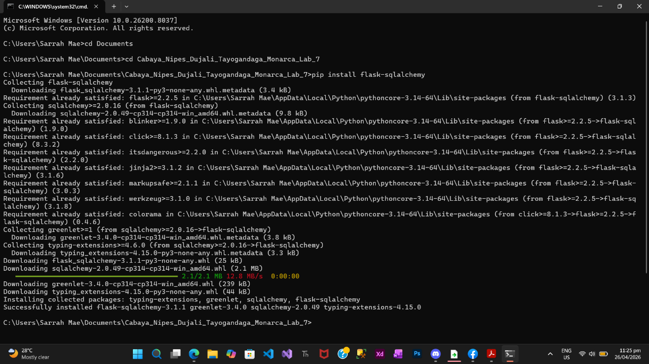

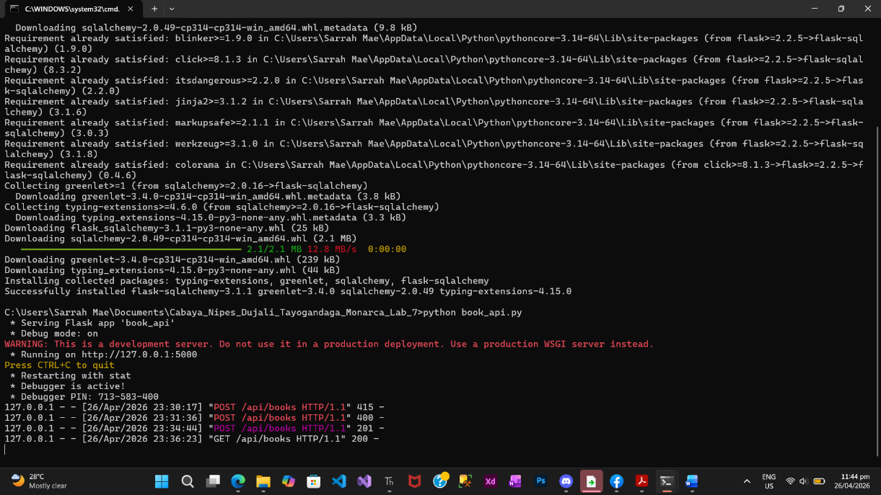
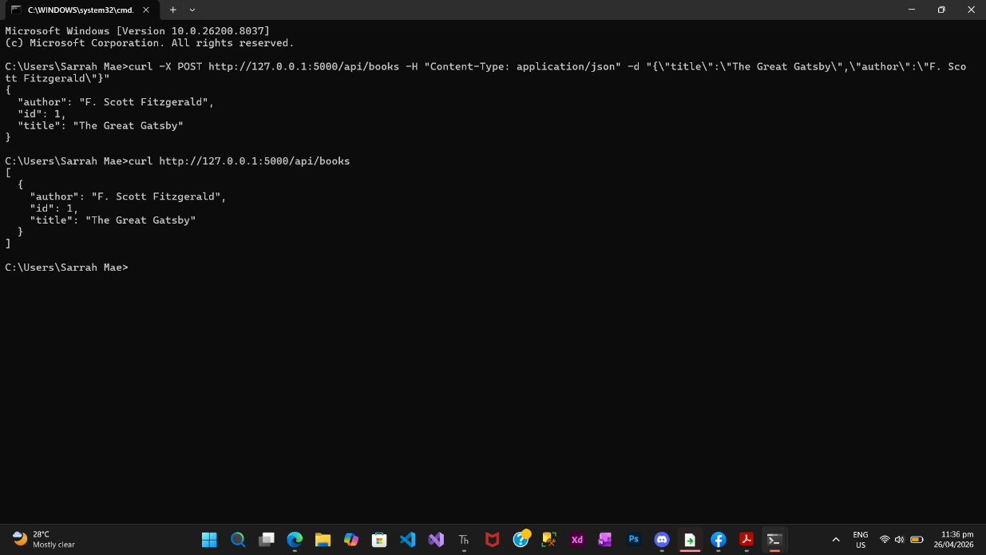

Lab Questions:
- The Power of Abstraction: In Lab 4 (Node.js), you wrote raw SQL strings like INSERT INTO products.... In this lab, you used db.session.add(). How does the ORM simplify the process of working with data?
- ORM makes working with databases easier by letting us use Python code instead of writing SQL. Instead of typing complex queries, we just create objects and use methods like db.session.add(). This makes the code simpler, cleaner, and less prone to errors.
- Schema Evolution: If you wanted to add a "Published Year" column to your books, would it be easier to do it in the Python Class (ORM) or by manually altering a SQL table? Why?
- It’s easier to update the Python class (ORM). You just add a new column in the model, and it updates the database structure. This is faster and avoids mistakes compared to manually writing SQL commands.
- The "Middleman" Role: In this architecture, if you swapped the SQLite database for a massive PostgreSQL database, would your routes (the GET/POST functions) need to change, or just the Configuration string? Why is this a major advantage for developers?
- Only the configuration string needs to change, not the routes. The ORM handles communication between the app and the database, so the same code works even if we switch from SQLite to PostgreSQL. This makes the app more flexible and easier to scale.

